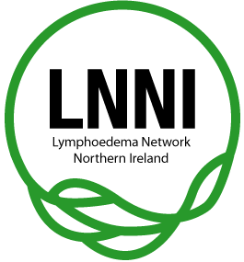

**Welcome to Belfast!!**

*Home to the Lymphoedema Network Northern Ireland (LNNI)!*

**5 reasons to visit Belfast:**

**1. OUR GEOGRAPHICAL LOCATION AND OPPORTUNITY TO REACH A WIDE DELEGATE BASE** With strong connections, both geographically and professionally, to the UK and Ireland there is great opportunity to attract delegates and new members from both of these areas.

**2. OUR ACCESSIBILITY** Not only do we have excellent access to Ireland and the UK, but we offer direct flights to 41 international destinations. Over 142 flights arrive daily into our 2 airports. We are also only 90 minutes drive from Dublin*, which offers flights to 198 destinations.

**3. WE ARE A WALKABLE CITY** Our compact nature means that delegates never have too far to travel when they are in the city. A range of budget and luxury accommodation is available within walking distance of the main conference venues, giving delegates a choice of where they would like to stay.

**4. WE ARE KNOWN FOR OUR HOSPITALITY** Belfast’s friendly, fun and unique personality will ensure that you are your delegates feel important, welcome and appreciated. We can offer a genuine welcome and professional hospitality.

**5. WE HAVE ‘TITANIC’ WORLD CLASS VENUES** With £1 billion invested in the last decade, we really are the new, unique destination. We are home to world class, award winning venues such as Titanic Belfast, Crumlin Road Gaol and the Giant’s Causeway Visitor Centre.

**\* 90 minutes to/from Dublin airport to Belfast City Centre.**

**Bus from Dublin Airport via** Air Coach,17 Great Victoria St, Belfast BT2 7GN ([Phone](https://www.google.co.uk/search?hotel_dates=2017-05-21,2017-05-22&site=async/lcl_akp&q=air+coach+belfast+phone&sa=X&ved=0ahUKEwi_5r6qxfTTAhVH1RoKHb7MDGMQ6BMIGDAE): 028 9033 0655 www.aircoach.ie) *or* Ulster Bus, 10 Glengall St, Belfast BT12 5AH ([Phone](https://www.google.co.uk/search?hotel_dates=2017-05-21,2017-05-22&site=async/lcl_akp&q=www+ulsterbustours+com+phone&sa=X&ved=0ahUKEwjT4MP6xfTTAhWL2hoKHahvDPsQ6BMIGDAE): 028 9033 7004)

Belfast Taxis cannot be flagged down in the street (other than Saturday nights) but a taxi stand is beside the Europa Business Centre (10 Glengall St, Belfast BT12 5AH) beside the bus/train station. A phone booking can also be made to book a taxi.

Visit Belfast Tourism: [www.belfastconventionbureau.com](http://www.belfastconventionbureau.com) +44(0)28 9023 9026

*LNNI (*[*www.lnni.org*](http://www.lnni.org) *)*

Airports and Flight Operators

1. George Best Belfast City Airport (inner city)

Belfast, BT3 9JH, Co. Antrim, Northern Ireland  
Tel: 02890 939093 Fax: 02890 939094

How to get to and from the airport: [www.belfastcityairport.com/To-From-the-Airport](http://www.belfastcityairport.com/To-From-the-Airport)



In peak season, we have 35 flights to four London airports alone. Typical return flights to Belfast are comparable to UK return rail costs.

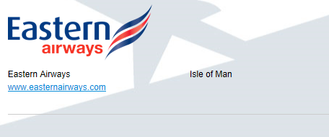

. 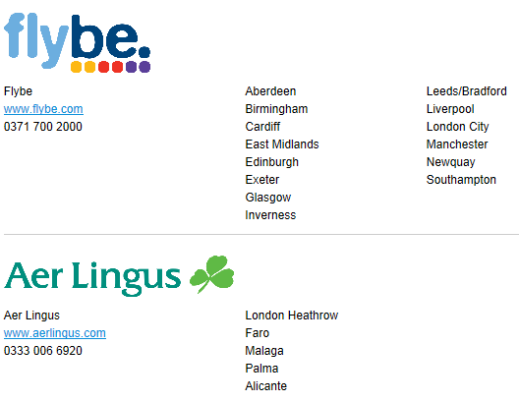

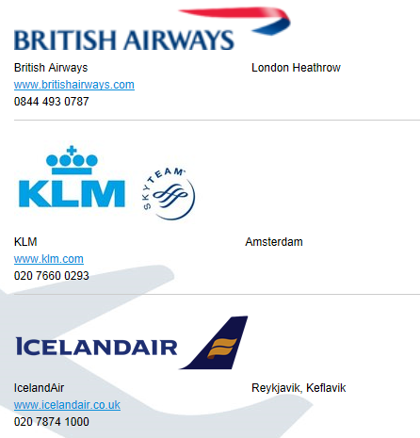

1. **Belfast International Airport**

Belfast International Airport Ltd  
Belfast, BT29 4AB, Northern Ireland

Phone 028 9448 4848

How to get to and from the airport: [www.belfastairport.com/to-from](http://www.belfastairport.com/to-from)



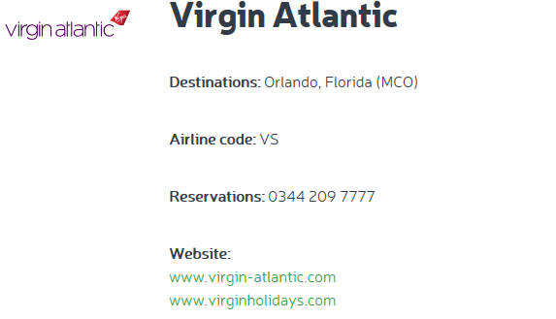

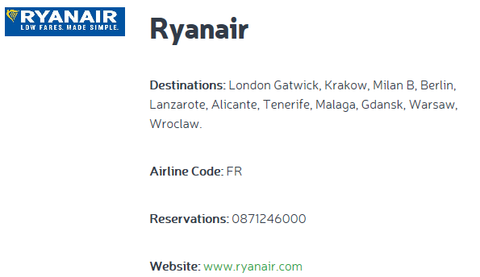

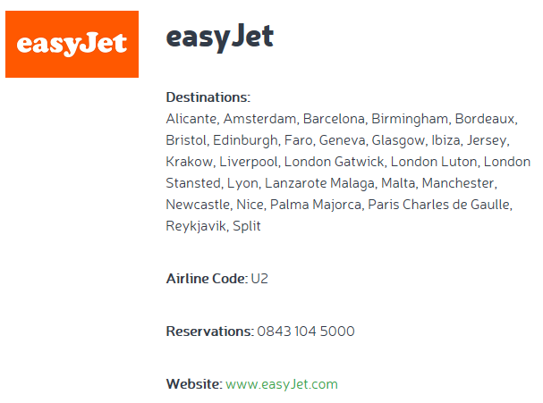

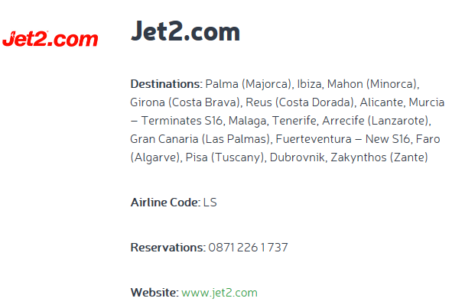

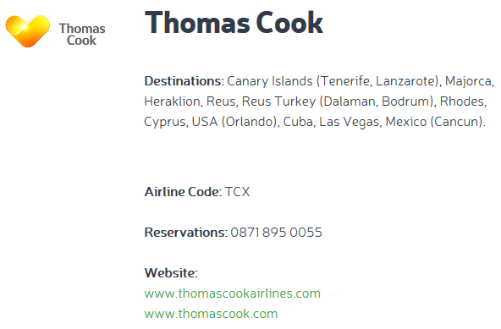

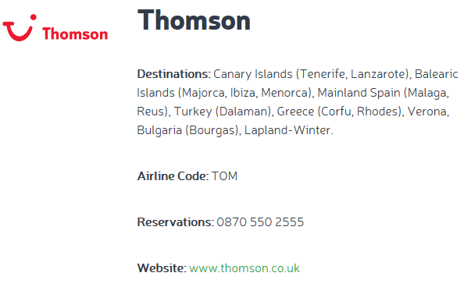

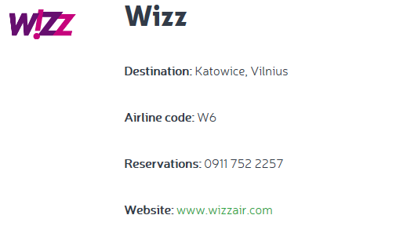

**Accommodation**

Belfast has 4,522 hotel bedrooms in the greater Belfast area with 7,000 bed spaces across all accommodation types. We have the big brands and local treasures with all major hotels within 5-10 minute walk of each other.

1. **Hotels:**

**The Ivanhoe Hotel and Inn**, 556 Saintfield Road, Belfast, N. Ireland, BT8 8EU

Situated 6 miles from Belfast City centre *(closest hotel to course venue)*

The hotel is ideally placed for easy access to Belfast International Airport (approx 30 minute drive) and Belfast City Airport (approx 15 minute drive). Free on-site car parking for 200 cars is one of The Ivanhoe’s many advantages. Public transport is readily available via bus – the stop is just across the road from the hotel and buses run very regularly to the City Centre. From there it’s only a short taxi-ride to the Titanic Centre, Belfast’s newest Visitor attraction. FREE Wifi access - this is available in all public areas and also in guest’s bedrooms.

T: +44 (0)28 9081 2240 E: [ivanhoecarryduff@gmail.com](mailto:ivanhoecarryduff@gmail.com) www.ivanhoeinn.co.uk

**Ramada Plaza Belfast,** Shaw’s Bridge,117 Milltown Road, Belfast, County Antrim, BT8 7XP *(also close to venue)*

The Ramada Plaza Belfast is a leading 4-star hotel is situated in the picturesque surroundings of Lagan Valley Regional Park, just 10 minutes by car from Belfast s thriving city centre. During your stay, you can enjoy the extensive leisure facilities at our La Fitness spa or pamper yourself at the hairdresser and nail bar. Suburbia Bistro offers contemporary dining while the Spice Club serves excellent Indian cuisine. The Green Room restaurant offers a gourmet menu featuring innovative Irish cuisine. The hotel s 120 luxurious en suite rooms are perfect for both the business and leisure traveller with air conditioning, flat screen TV, mini fridge and facilities for making tea and coffee. Rooms feature a king-size bed or 2 queen-sized beds family rooms with a king and queen-sized bed are also available. Guests can enjoy free wifi and ample free car parking. Please note the property is now completely non-smoking.

**Malone Lodge Hotel & Apartments,** 60 Eglantine Avenue, Belfast, County Antrim, BT9 6DY [view map](https://maps.google.co.uk/maps?q=54.58155000,-5.94221000) (*the apartments make a good alternative to hotel rooms for those staying for conferences and courses*)

Relax and rejuvenate in our chic Victorian townhouse hotel, where warm ambiance, Irish hospitality and contemporary luxuries will embrace you. Nestled in the peaceful, leafy suburb of South Belfast - just minutes from the City Centre - the Malone Lodge offers a choice of 108 rooms in total, combining luxury hotel guestrooms and elegant suites, as well as 23 five-star apartments. Only minutes from the city centre, set in the luxurious tree lined avenues of the Queens University Quarter of South Belfast, just off the exclusive Malone Road & fashionable Lisburn Road, Belfast, surrounded by beautiful parks and gardens this luxury is reflected in every aspect of the Hotel. As Belfast Hotel of the Year & Northern Ireland Tourist Board Highly Distinguished Hotel, where better to treat yourself when visiting Belfast than the award winning Malone Lodge Hotel, Apartments & Suites, offering you the highest standards where you can relax in luxury and enjoy a perfect stay The luxurious surroundings of the hotel foyer allow you to relax and sink into deep cushioned sofas before deciding on where to dine for the evening. As NI Head Chef of the Year, Taste of Ulster and AA rosette winner, you can enjoy food from our head chef Dean Butler and his team, whose recipe for success is straightforward serving simply good food every day! With an exceptional reputation for food our success is built on using the finest local produce to create the perfect dining experience for you. In addition to our guest rooms, special events and award winning food, Malone Lodge offers a complimentary private Car Parking for guests, wifi access throughout.

**Dukes At Queens Hotel,** 65-67 University Street, Belfast, County Antrim, BT7 1HL [view map](https://maps.google.co.uk/maps?q=54.58600000,-5.93092000)

Dukes at Queens showcases a lavish environment at the heart of Botanic Avenue in Belfast. Our guests will experience a retreat from the bustle of the city into a world of indulgence and wellbeing. Formerly Dukes Hotel, the new transformation into Dukes at Queens brings with it modern sophistication and intuitive service. Dukes at Queens is the ultimate expression of style and opulence, making it a perfect venue for corporate business trips, romantic getaways or a long leisurely weekend. Dukes at Queens is situated within a few minutes walk of Belfast s famed Queens University and Botanic Gardens. Belfast s finest boutique hotel enjoys superb facilities throughout and offers guests a haven of peace within the vibrant capital city. Contemporary style luxurious accommodation, a world-class brasserie, relaxing bar, bustling café and with all the personal amenities one could desire, are proud attributes of our service. An environment complimented with warm and friendly staff makes Dukes at Queens one of the most desirable Boutique Hotels in Belfast. Enjoy the best of Belfast with Dukes at Queens. Please note that Dukes at Queens does not have a Car Park. Parking is On Street Only. Please be advised that the Hotel has Entertainment every Friday & Saturday Night with Music Playing Until 1am.

**Benedict’s of Belfast,** 7-21 Bradbury Place, Belfast, County Antrim, BT7 1RQ [view map](https://maps.google.co.uk/maps?q=54.58891000,-5.93493000)

Welcome to Benedict’s of Belfast an ultra-trendy 4 star boutique style hotel. The award winning hotel boasts Executive rooms with a spa bath together with a selection of standard double and twin rooms. All rooms are fully en-suite and have a fast, free, broadband Wi-Fi facility. Executive rooms have large wide-screen plasma televisions. All the bedrooms benefit from Freeview television with optional pay-per-view channel facilities. Each individual room is finished to the highest standards featuring feather topped luxurious mattresses and 600 thread Egyptian cotton linen. Benedict’s has a spacious themed bar packed with a mature cosmopolitan crowd enjoying live music and top DJs with a late licence every night. The popular first floor restaurant is widely renowned as one of the city s busiest and most popular (reservations are recommended) and serves a wide variety of world cuisine. Check the restaurant section for details of our famous Beat the Clock offer available 7 nights per week between 5.30pm-7.00pm. Located at the heart of the action in Bradbury Place, off Shaftesbury Square, Benedict’s has easy access to all Belfast has to offer.

**Travelodge Belfast Central,** 15 Brunswick Street, Belfast, County Antrim, BT2 7GE [view map](https://maps.google.co.uk/maps?q=54.59529000,-5.93326000)

City centre budget hotel, the ideal location to base yourself while working or visiting Belfast. Travelodge Belfast Central is a central hotel close to the City Centre. It offers great value for travellers on a budget or for those who are just in on a flying visit. All of the city’s best attractions are on your doorsteps, with many restaurants, clubs, cinemas and pubs just a stroll away, including the fabulous Crown Liquor Saloon. The train & bus station are close to the Travelodge which service all major routes. Continental breakfast is provided in Olio s Restaurant attached to the hotel, which serves breakfast, lunch and dinner Mon-Fri between 7am and 10pm, Sat between 8am-10pm and Sun serving breakfast between 8am-11am and dinner between 6pm-9pm. Parking is on street and is pay and display at £1.30 per hour. WIFI is available in our guests’ rooms for a small fee of £5 for a 24 hour pass.

**Ibis Hotel**, Belfast, Castle Street, NORTHERN IRELAND, BT1 1HF – BELFAST, UNITED KINGDOM This modern ibis Belfast City Centre Hotel is located in the heart of Belfast. All the bedrooms offer comfortable double or twin beds, air-conditioning, flat screen TV, tea/coffee facilities, hairdryer and work space. Also included is free Wi-Fi and discounted secure parking nearby. Great food is served 24 hours a day including a great value cooked breakfast. There is a snack vending machine within the hotel as well as connecting rooms to cater for families with young children. In reception there is a safe deposit box to store all of your valuables when you leave the hotel for a day of exploring. (+44)2890/238888 Fax: (+44)2890/891890

1. **Bed and Breakfasts**

**Maranatha House**, 254 Ravenhill Rd, Belfast BT6 8GJ, [Phone](https://www.google.co.uk/search?hotel_dates=2017-05-21,2017-05-22&site=async/lcl_akp&q=maranatha+house+phone&sa=X&ved=0ahUKEwjekZjhwfTTAhUCBcAKHSx7BAIQ6BMIGTAE): 028 9046 0200 Set in a redbrick townhouse overlooking Ormeau Park, this casual, family-run bed-and-breakfast is 1.8 miles from Belfast city centre and 2 miles from Titanic Belfast.   
The 10 rooms have understated furnishings and decor, and come with free WiFi, flat-screen TVs, and tea and coffee making facilities. Cooked Irish breakfast and a continental buffet featuring homemade bread are served in the airy dining room. Parking is complimentary.

**Ravenhill Guest House,** 690 Ravenhill Rd, Belfast BT6 0BZ [Phone](https://www.google.co.uk/search?hotel_dates=2017-05-21,2017-05-22&site=async/lcl_akp&q=ravenhill+guest+house+phone&sa=X&ved=0ahUKEwjuqb6fwvTTAhVE7hoKHRS1DD4Q6BMIHTAF): 028 9020 7444 2-star hotel, Classic rooms in a Victorian B&B offering a guest lounge with a wood-burning fireplace. Free Wi-FiFree breakfast.

**Ardmore Loading...**

**Bed & Breakfast**, 7 Ardmore Ave, Belfast BT7 3HD [Phone](https://www.google.co.uk/search?hotel_dates=2017-05-21,2017-05-22&site=async/lcl_akp&q=ardmore+b%26b+phone&sa=X&ved=0ahUKEwiiw4f5wvTTAhXFPxoKHUK4A_sQ6BMIGDAE): 07725 552175

**Namaste Lodge**, Loading...

7 Rushfield Ave, Belfast BT7 3FP [Phone](https://www.google.co.uk/search?hotel_dates=2017-05-21,2017-05-22&site=async/lcl_akp&q=namaste+lodge+phone&sa=X&ved=0ahUKEwjokeqfw_TTAhWJcBoKHTD9BQ0Q6BMIFzAE): 07714 200132