
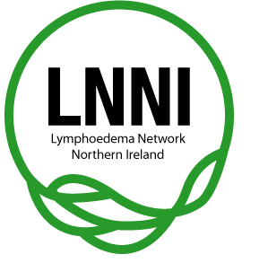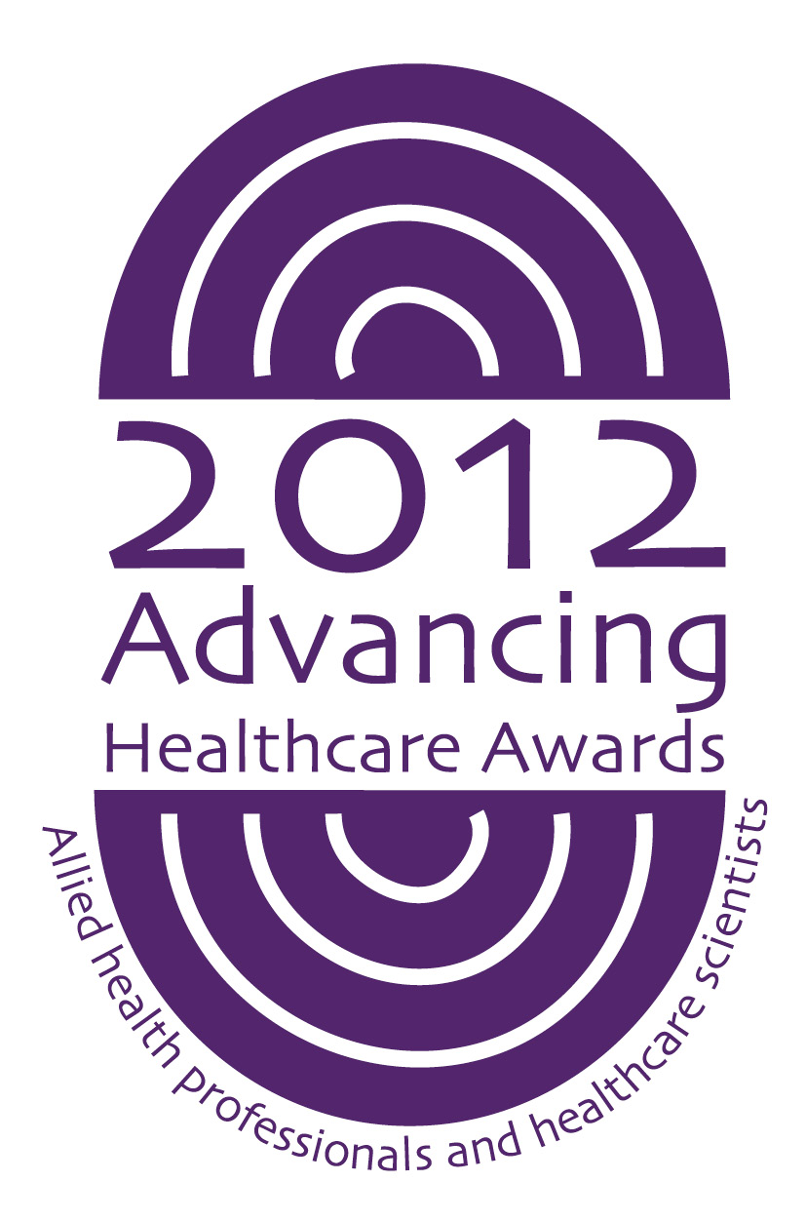

Lymphoedema Network Northern Ireland (LNNI)

Annual Report 2013/14

Agreement Cover Sheet

This annual report has been prepared by:

Chair of LNNI Board
Name: Mrs Clare McGartland
Date agreed June 2014

LNNI Project Lead
Name: Ms Jane Rankin
Date agreed June 2014

LNNI Board members agreed the report on
Date agreed 17th June 2014
Annual report review date: AGM, June 2015

- Introduction
This report relates to work undertaken by the Lymphoedema Network Northern Ireland (LNNI) during the year 2013/14.

- Clinical Lead’s address
The Lymphoedema Network Northern Ireland Board has continued to provide an executive platform regarding leadership and direction to the work of the network whilst ensuring that all those with lymphoedema in Northern Ireland have equal access to high quality person centred care.

The Team have continued to review the work plan, demand and capacity over 2013/14. Modernisation continues with a pilot of controlled discharge (similar to the Transforming Cancer Follow Up programme) whereby care of the stable/low risk patient is transferred to self management under GP supervision. The teams are beginning to audit the re-referral cases, but to date there have been few, suggesting a positive response from both service users and primary care.

The team has also addressed new challenges, such as the increasing number of babies, and worked with other professional groups regarding genetics, DVT management and coronary team education.

Whilst the focus of the network is regional, LNNI has continued to extend its links both nationally & internationally. The management team have continued to assist senior HSE teams to develop and inform their plan for a clinical network development in the South of Ireland with potential for cross-border working. The work of the network has also been recognised by the British Lymphology Society as the LNNI policy for management of patients with obesity related lymphoedema has become the foundation of what is now a national document. This was also presented at the International Lymphoedema Framework meeting which is a significant accolade regarding service design and management.

The project team would again like to acknowledge the continuous energy and support of the LNNI Board; all members have worked consistently and effectively to develop not only the profile of Lymphoedema, but the service across Northern Ireland.

- Background and rationale
In 2002 the Chief Medical Officer commissioned a review of regional lymphoedema services: The Report of the Lymphoedema Services Review Group (2004). The Lymphoedema Network Northern Ireland (LNNI) was launched in 2008 with a vision to change the emerging picture of the condition. This work is supported by the cardiovascular and cancer service frameworks.
Representation on the LNNI Board includes:
- 5 service users
- Clinical leads from each trust
- Commissioner
- General Practitioner
- Assistant Director of commissioning for Regional Services and Strategic Planning, Health and Social Care Board
- LNNI Management team (chair and lead)
The Board also invite a Senior Management Team representative from each trust to encourage communication and understanding. Service managers are also copied into all communications regarding agendas and agreed minutes.

4.0 Meetings schedule and attendance 2013
For decision making / approval 60% of key members with a minimum of one patient representative, one trust clinical lead and one member from the management team must be present. All meetings achieved the required quorum. In 2012 the Board agreed to reduce meetings to two per year.

 | 27th June 2013 | 10th December 2013
PPI | √ | √
Trust clinical lead | √ | √
Trust SMT representative | √ | x
Commissioner/DHSSPSNI | √ | √
LNNI Chair/Vice Chair | √ | √
More than 60% Board  membership | √ | √

5.0 Patient and Carer Feedback Involvement
Regional patient stakeholder events have been held since 2008. In response to previous PPI feedback, the Trust leads from the Western, South Eastern, Southern and Northern Trusts continue to support smaller groups which provide PPI leadership and support for each Trust team.

The Board PPI representatives supported the LNNI team to build upon the self management pilot and initiated the design of the “Return to Work” information leaflet in conjunction with the Occupational Therapy Team from the Cancer Centre, BHSCT.

The patient representatives (or alternates), attend LNNI Board meetings, participate in electronic (e-mail) document reviews/additional communications and represent LNNI at other events e.g. Long Term Conditions Alliance Northern Ireland. The inclusion of our patient representatives has continued to enrich all aspects of LNNI discussions and ensures that patient voice continues to be at the centre of our work.

- Key Achievements
Throughout the 6th year (Feb 2013 - 14):
- Excellent feedback from service user satisfaction audits across region with focus for next year’s work programme
- Development of genetic clinics for those with congenital lymphoedema
- First Family Event for those with children who have lymphoedema; also encouraging attendance at national family events and provision of data to national paediatric register
- JR elected as Vice Chair of the British Lymphology Society
- Membership of the British Lymphology Society’s (BLS) obesity, tariff and children’s groups
- Membership of Long Term Conditions Alliance Northern Ireland Board
- 1Poster presentations at national BLS 2013 annual Conference
- 1 presentation at International Lymphoedema Framework 2014
- JR awarded runner up in Institute of Healthcare Management AHP Manager of the year
- Cross border relationships strengthened
- Continued development of website www.lnni.org with an emphasis on providing patient information
- Regional complex clinic: reduced to 1 per year in acknowledgment of the up-skilling of the teams with the development of local trust support resources. Clinics still available to review potential for surgical assessment.
- Continued use of minimum data set to inform reporting
- Continued to lobby the Department of Health, Political Parties and Ministers regarding key issues affecting the service e.g. increasing levels of obesity, impact of DVTs etc
- Research project: bioimpedence lymphoedema screening programme - preparing for publication (sponsored by Friends of Cancer Centre)
- Research project: psychological impact of lymphoedema, assessment of screening tools for clinical use and impact on concordance - new MSc health psychology student leading on project.

7.0 Key Challenges for 2014/15
- Vacancies
The teams have been faced with a very difficult year due to multiple maternity and sick leaves (with no backfill) together with unfilled vacancies. This has severely limited opportunities to develop teams as all available staff have been utilised for clinical purposes in order to keep meeting the 9 week AHP access target.

It is anticipated that staffing will not improve until the end of this financial year.

- Incidence change:
The research based estimation of this patient population has changed dramatically:
- In 2008 - 1.3 per 1000 (2274 patients)
- In 2011 - 2 per 1000 (3600 patients)
- In 2012 - 3.99 per 1000 (potentially 7182 patients).
This change has been corroborated by the on-going LNNI referral audit which states that 4517 referrals have been received from 2010. The initial 2008 regional caseload on which the service was designed and financed is therefore an underestimation requiring a capacity and demand exercise.

- Population change:
The inequity shown in 2008 with the majority of patients coming from a cancer background has been corrected with equal access for all sufferers; this new population has proven to be more complex and chronic. Multiple co-morbidities exist requiring longer treatment periods and more joint working with other teams such as tissue viability; this in itself has challenges as different professional groups work to different guidelines. The team has met with tissue viability colleagues and will take this forward in 2014/15 to investigate new models of working. This group also reflect the national problem of increasing obesity.

Lipoedema is a condition which, whilst appearing similar in physical appearance to lymphoedema, has a differing pathology. The teams are not funded to mange this condition but have 60 patients on the caseload. LNNI was asked a Ministerial question regarding service provision for this population and provided a formal briefing which may benefit future bids.

- Obesity issues:
This new population also has much higher BMI scores than the average population.
- 13.06% of this population has a healthy BMI (i.e. less than 25); this percentage is reducing year on year
- 60.97% have a BMI greater than 30, which is obese. This is greater than the regional average for the general population (and worsening from 2012 and 2013 LNNI reports)
As such the management of this group is made more complex by the health and safety aspects requiring correct handling equipment, additional support staff and domiciliary care.

- New technologies:
Numerous new technologies are entering the lymphoedema market to support established care. The LNNI clinical team are currently piloting the deep oscillation devices that have proved to be useful regarding self-management in other parts of the world.

- Cancer survivorship:
Patients with cancer are living longer due to the developments in cancer management. Patients with cancer-related lymphoedema are therefore living longer and adding to the increasing prevalence rates.

- Future modernisation
The network continues to utilise data, national/international practice and patient feedback to focus its work plan to continue to increase effectiveness and efficiency.

- Long term conditions model:
The network has reviewed the 2012 DHSSPSNI Long Term Conditions Framework and identified a process to increase the active role of the patient to one of shared partnership with the healthcare staff. A pilot programme was undertaken by the Western HSC Trust and, whilst those who attended felt it to be very beneficial, the programme had a large dropout rate questioning its feasibility regarding resource utilisation. The Belfast HSC Trust has started a physical activity pilot for those with a BMI over 30 in partnership with the Active Belfast/Belfast Strategic Partnership which will be reviewed for possible roll out.

- Supported self-monitoring and discharge:
The South Eastern HSC Trust model facilitates patients with well-controlled lymphoedema, and who deem themselves to be competent, to manage their own condition and link with GPs regarding long term needs; this has been modified to suit all trusts and is currently being reviewed. This is reducing the impact of rising prevalence rates and allowing the more complex patients to remain on the specialists’ case loads. Re-referrals are being audited to assess the pathway change.

- Paediatrics and related genetics assessment:
The team will continue to build upon the 2013/14 work to engage with families to foster support networks and shared learning. All families will be encouraged to attend specific lymphoedema genetics clinics to aid both regional and national research and mapping.

- Shared working:
The team have started work with the regions TVN and Leg Ulcer Forum teams to develop a regional partnership to improve primary care vascular services including the further education of district nursing. It is proposed to hold a workshop in September.

- Furthering prevention role:
The network currently actively promotes awareness/prevention activities related to cancer surgery. The minimum data set has highlighted the increasing referral rate as a result of incorrect long term management of DVTs. The team is working in partnership with clotting clinics and DVT services (as per 2012 NICE guideline) also, with the identifiable clinical specialities, such as chemotherapy.

Coronary artery by-pass grafting also seems to be a referral group and the LNNI team are discussing with this team regarding education options to enhance patient self-monitoring and the awareness skills of healthcare professionals.

- Surgical developments:
Recent improvements in lymphoedema liposuction have made this a viable option for some patients who develop abnormal fat deposits related to the condition. This is not currently available regionally. A new vascular plastic surgeon has been employed by the Belfast HSC Trust who is qualified in routine liposuction. He requires additional training to achieve the lymphoedema techniques and would need contracted sessions to perform this surgery. The surgeon attends the LNNI Complex Clinic once a year to review potential candidates whilst funding is debated. The team have investigated the potential for accessing a Scottish consultant regarding one assessment clinic per year in Belfast; however this has not proved possible. The only remaining option is therefore to establish a regional resource or to consider EU options such as The Netherlands.

- Developing national/international linkages:
The network is continuing to develop links with the British Lymphology Society and is influencing the work plan of this national group, regarding obesity, tariff and paediatrics in particular. Other links include the national Lymphoedema Support Group, Macmillan and the Charted Society of Physiotherapy which provide education opportunities. The network also links with the Welsh and Scottish project leads, and is part of a new review group which will look at pan United Kingdom services and governance, and will form a strategic partnership.

The network has also been asked to consider becoming a Framework following on from work by the International Lymphoedema Framework which would create access to international resources and projects to look at epidemiology and care provision.

For further information on the LNNI Board, please follow this link: www.lnni.org

