Title | Regional Lymphoedoedema Demographics and Aetiology Report - April 2012
Summary | A review of the regional lymphoedema minimum data set (Lymphdat) themed statistical information regarding local services and users (for information saved as of 31st March 2012)
Purpose | To build upon the baseline measurement of services and user profiles established in 2011 to influence future service delivery and also report on LNNI service improvements
Operational date | 19th June 2012(LNNI Board AGM)
Review date | annual
Version Number | 1.0
Supersedes previous | -
Lead Responsible | LNNI Lead
Author(s) | Jane Rankin
Contact details | Lymphoedema Network Northern Ireland (LNNI), jane.rankin1@belfasttrust.hscni.net, 028 9069 9430

Amendments:
Date | Version | Author | Comments
 | 2.0
 | 3.0
 | 4.0

Document authorisation and sign off:
LNNI Board | C McGartland | Authorise | June 2012
LNNI Chair | C McGartland | Sign off | June 2012

Regional Lymphoedema Demographics and Aetiology Report

1.0 Background
This report complements the inaugural demographic report from April 2011 and utilises the same electronic data bases.

2.0 Process
Two data bases are utilised for this report:
  - Lymphdat, the network’s minimum data set, is used to provide data for the cancer and cardio vascular frameworks; it provides data regarding regional aetiology and demographics for the population of patients with lymphoedema as of 31st March 2012.
  - Referral/ review and waiting list audit: data is also recorded monthly as a regional exercise, alongside numbers waiting for assessment/treatment and period of wait.

3.0 Results and discussion
Research suggests that the prevalence rates are 1.33 per 1000 for all ages, rising to 5.4 in the over 65 age group (Williams et al, 1996). The Province should therefore have 2274 (as of 2005 population estimate) service users for the overall regional population; it is thought that because of the lack of agreed international lymphoedema definition and measurement technique, that this may be an underestimate (CREST, 2008).

The 2012* Lymphdat figures show that 2119 (300 male and 1819 female) service users are recorded (93.18% of the estimated patient population). This is an under-reflection of actual incidence figures as the Southern Health and Social Care (HSC) Trust has not uploaded data to Lymphdat for the year 2011/12; this report therefore only reports Lymphdat data for the other four trusts. The actual CREST estimation may therefore already have been met if all regional data had been recorded.

3.1 New Referrals and Review Appointments:
The regional record of new referrals and reviews does reflect all five trusts as data comes from a separate record audit tool. Table 1 details the continued increase in referral and review rates:

Table 1: Trust new referral and review data
Year | New referrals | Review Appointments
2010 | 869 | 2204
2011 | 1086 | 3059

Graphs 1 and 2 represent the changing new referral pattern from 2010 to 2011. The January – June 2010 spikes in the Southern HSC Trust’s statistics reflect the recording of post-mastectomy assessment which was initially recorded as lymphoedema activity; this was amended in July 2010 in recognition of the role evaluation and duties. The figures for 2010 cannot be amended to reflect the actual mis-recorded numbers however graph 1 does show a definite change in rates post July 2010 for the trust.
*2011 figures: 1717 (223 male and 1494 female)

Graphs 1 (2010) and 2 (2011): new referral patterns

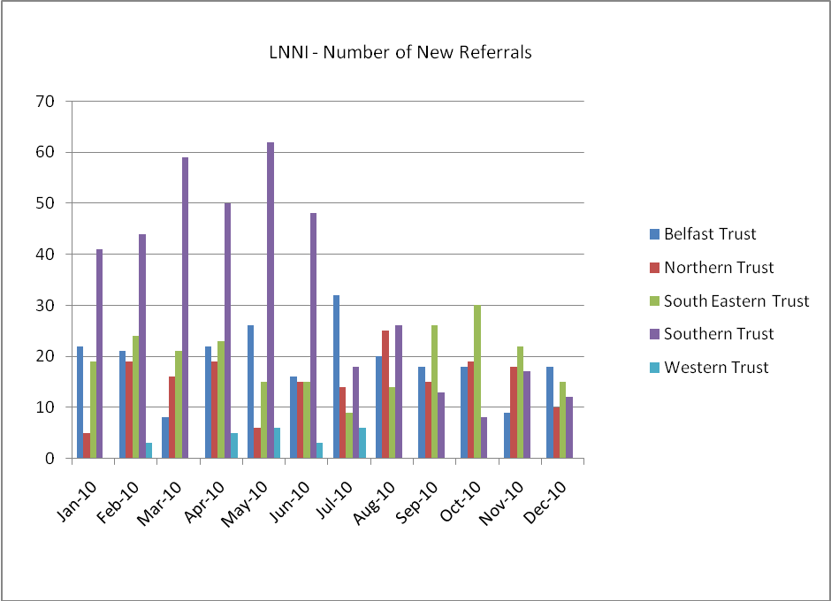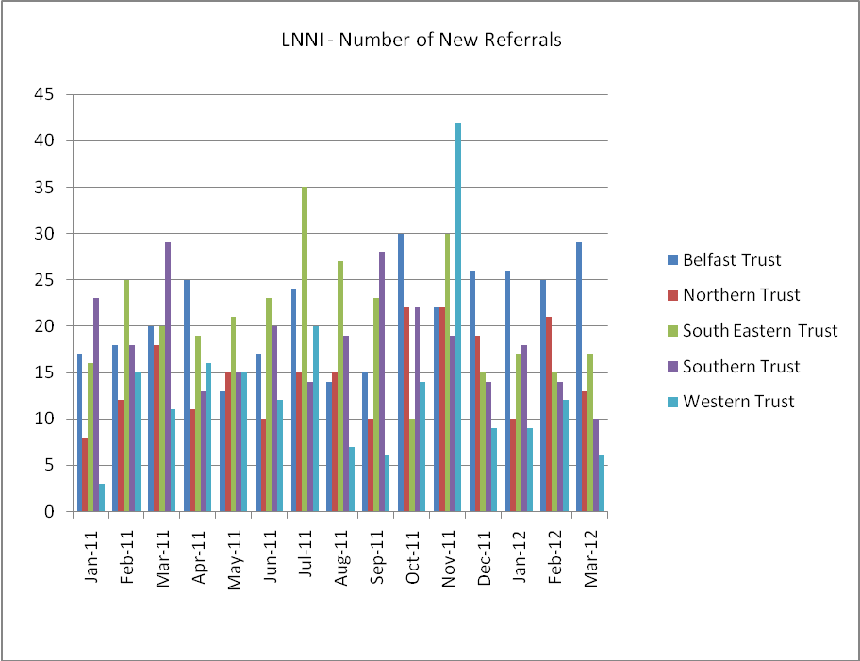

This continued increase in incidence and associated prevalence (as a long term condition) has impacted on regional service provision particularly where there have been uncovered periods of absence (maternity and sick leave etc) and slow recruitment patterns. A pilot of supported self-management and review (with fast access back into service) is currently being undertaken in the South Eastern HSC Trust (to address prevalence) for those deemed to be competent.

The teams are also utilising the principles of the long term condition model, stratifying care levels and promoting supported self care where deemed possible (on an individual basis). Additional information leaflets, such as nocturnal bandaging and garment care, have been developed and are in use across the Province. The impact of prevalence on the demand for review appointments is shown in graphs 3 (2010) and 4 (2011).

Graphs 3 (2010) and 4 (2011): prevalence rate impact on review appointments

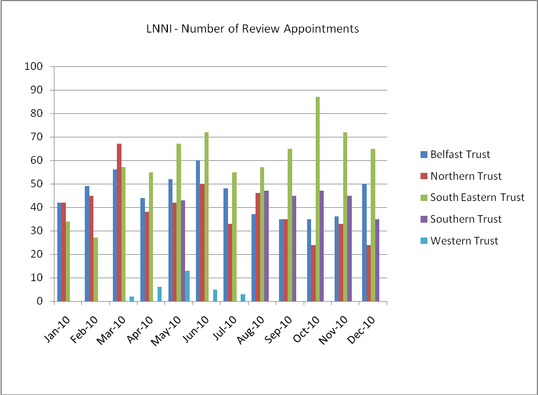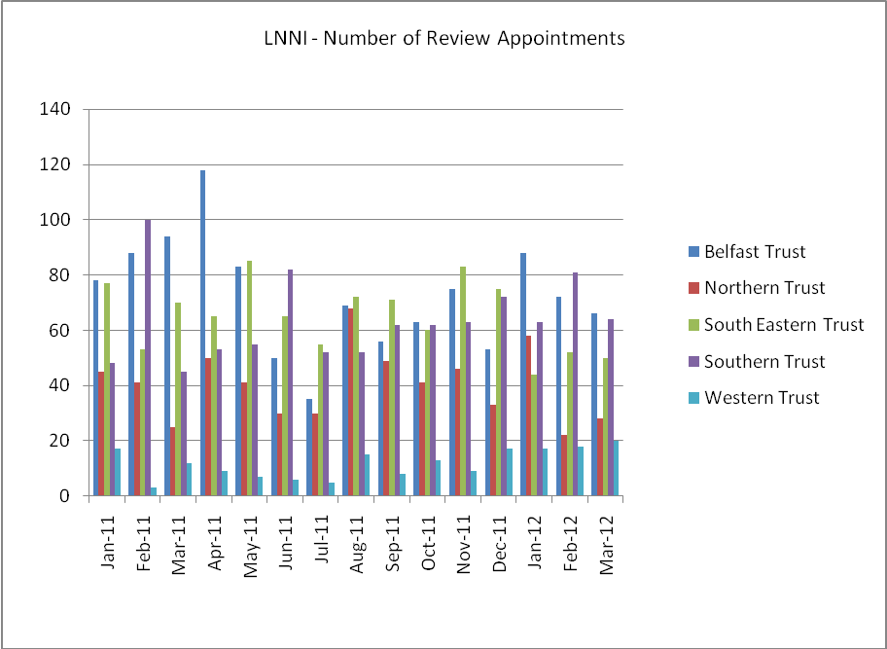

Trust waiting times (graphs 5 and 6) are maintained within the 9 week DHSSPSNI target with occasional breaches (graphs 7 and 8) due to maternity or long term sick leave – which impact greatly on such small teams.

Graphs 5 (2010) and 6 (2011) waiting times to assessment
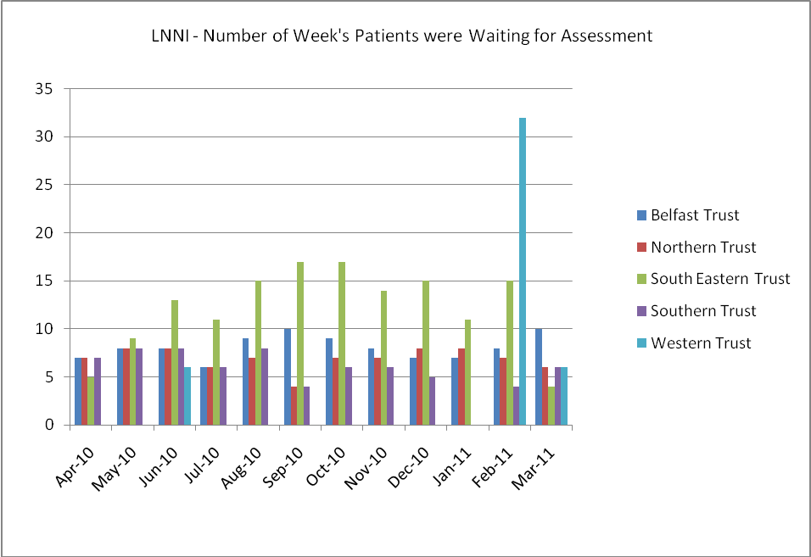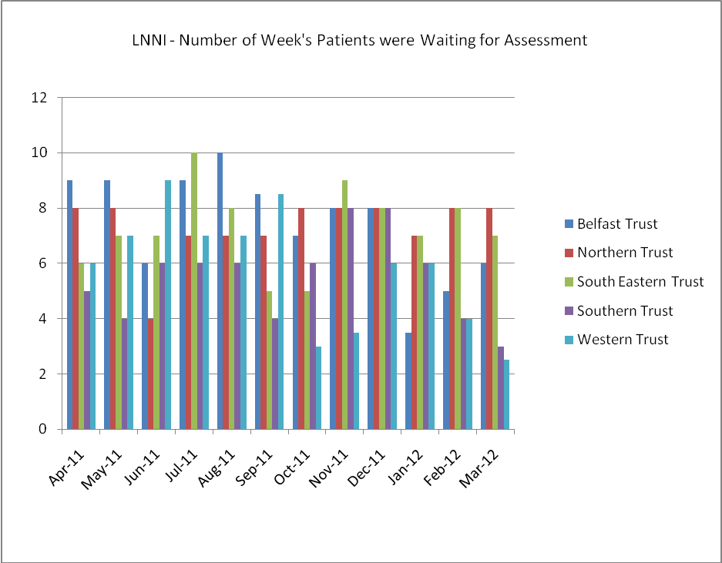

Graphs 7 (2010) and 8 (2011) breaches
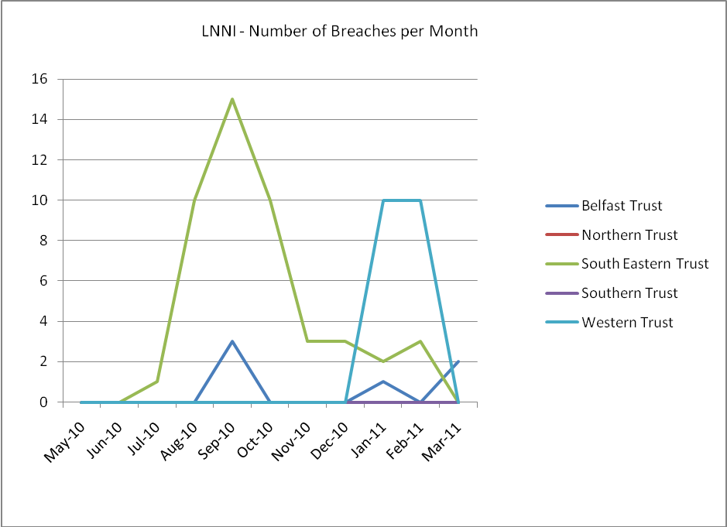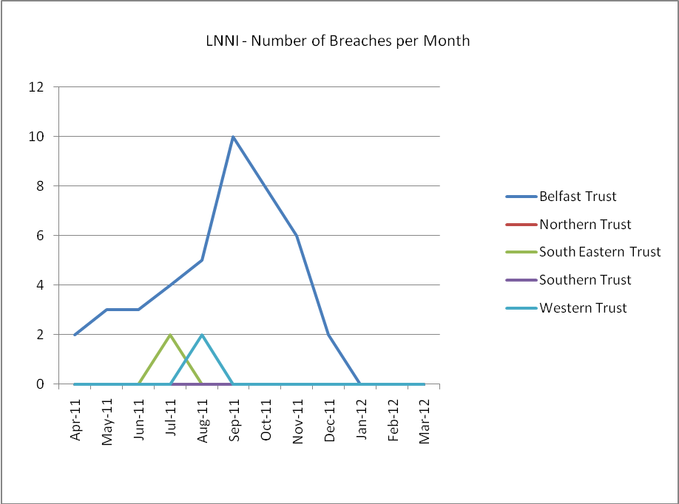

The unusual increase in patients waiting to be assessed shown in graph 5 (February 2011 – Western Trust) is explained by the return to work of the trust lead and the collation of waiting list patients not able to be seen in her absence. The South Eastern Trust also showed high numbers during 2010 as it was also a relatively new service and having to cope with referrals.

3.2 Trust incidence registered with Lymphdat
Table 2 provides a breakdown of patients registered with Lymphdat in 2011 and 2012. Each trust has a minimum of 3 specific clinic locations plus limited domiciliary services. This was deemed to be necessary after the LNNI initial mapping of services (2008) in respect of the wide service areas of the new “super trusts”.

Table 2: Trust clinic locations
 | Belfast (BT) – total patients | Northern (NT) – total patients | South Eastern(SET) –total patients | Southern (ST) – total patients | Western (WT) – total patients
2011 | 353 | 368 | 281 | 478 | 236
2012 | 492 | 386 | 439 | 483 | 318
3.3 Preferred language and ethnic group
The majority of services users reported that English was their language of preference; the others (0.4%) reported: Arabic, Bulgarian, French, Hakka, Polish and African.
Regarding ethnic groups, 99.60% reported being white and the remaining a combination of Black African, Indian and Pakistani. This figure is unchanged from 2011 and appears low for general NHS contacts, but may reflect the ethnic variations in aetiological presentation and will be monitored over time. Currently there are no figures to compare this statistic with other regional outcomes.

3.4 Age group
Table 3/graph 9 shows the regional age distribution which reflects the age range model proposed by Williams et al (1996) regarding the peak after age 65 years. This is significant for future service planning and indeed service provision expectations, as other co-morbidities are to be expected in latter age ranges. Many age related potential co-morbidities will require lymphoedema management to be modified or even contraindicated for some aspects, for example, diabetes, active cancer, uncontrolled heart or renal failure etc. Cancer in particular is recognised as a disease of the elderly population which may significantly influence the results. This may, after a longer period of data collection, influence the practical potential key performance indicators for the cancer and cardio vascular frameworks, which must recognise the impact of co-morbidities on safe treatment provision.
Table 3: Age range
Age range | Patient numbers
0 – 10 | 3
11- 20 | 9
21- 30 | 36
31- 40 | 126
41- 50 | 321
51- 60 | 436
61- 70 | 554
71 - 80 | 407
81 - 90 | 205
91 - 100 | 22

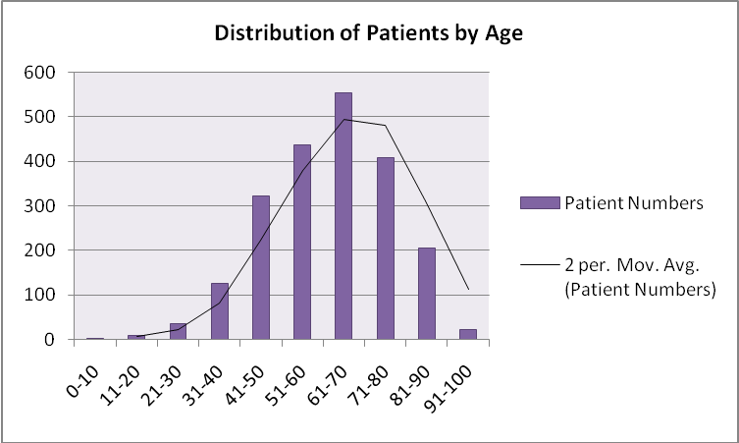
Graph 9: Distribution of patients by age (with trendline)

3.5 Living arrangements
43.01% (2011 figures 29.18%) of the patients recorded live alone. This may be significant if assistance is required to fit or remove compression garments which are part of the life long management of lymphoedema, and may result in social care requirements to maintain clinical outcomes and promote life-long management. Patients having multi-layer bandaging will also require assistance with transport to clinic locations as the bandages can affect the ability to drive necessitating access to local clinics, ambulance services or supporting carers. A new form of bandaging, which is more user-friendly, is being trialled in the Southern HSC Trust, and wider training planned for June 2012.

3.6 Reasons for discharge
11.1% (2011 figures 8.04%) of the patients recorded were discharged from the service. The reasons are shown in table 4. Lymphoedema is a chronic condition which requires monitoring and continual issuing of prescribed medical compression garments. The current pilot will inform practice regarding discharge to care of GP for those patients deemed competent.

Table 4: reasons for discharge
Reason for discharge | Numbers of patients 2011 | Numbers of patients 2012
Patient choice | 28 | 50
Latency (stage 0) plus 1 year | 4 | 12
Death | 38 | 69
Non-compliance | 3 | 23
Referral to GP for long term management of static self-monitoring patient | 48 | 51
Inappropriate referral | 3 | 8
Did not attend for assessment/treatment | 14 | 22

3.7 Body Mass Index (BMI)
It has been recognised that BMI is an indicator of obesity; obesity has been shown to impact on the effectiveness of lymphoedema management. The greater the BMI the less effective the treatment, and the more likely the treatment outcome will not be maintained.

A BMI baseline is recorded in table 5/graph 10 which show that only 15.87% of the patients recorded are a healthy weight. Until recently, whilst it has been observable that this is an issue for many of the patients, the resources have not been available to objectively provide an assessment figure. Most trusts have recently gained access to bariatric scales and are beginning to include this in all records. The NICE Obesity guideline (2006) defined BMI levels are also recorded in the table.

Table 5: BMI levels and definitions
BMI range | NICE 2006 definition | Patient numbers 2011 (n=54  = 3.14% of records) | Patient numbers 2012 (n=397  = 18.74% of records)
0 – 18.4 | Underweight | 0 | 2
18.5 – 24.9 | Healthy weight | 11 | 63 (increase of 82.54%)
25 – 29.9 | Overweight | 14 | 126 (increase of 88.89%)
30 – 34.9 | Obesity I | 9 | 86 (increase of 86.52%)
35 – 39.9 | Obesity II | 5 | 54 (increase of 90.74%)
40 and over | Obesity III | 15 (including:  - 3 BMI > 50  - 1 BMI > 65) | 120 (increase of 87.5%) (including:  - 71 BMI 40-49  - 36 BMI 50-59  - 11 BMI 60-69  - 2 BMI 70-79)

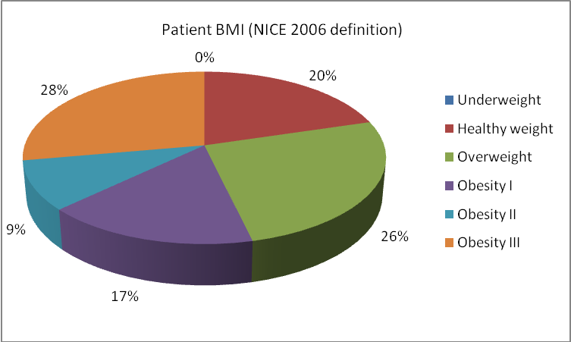

Graph 10: Lymphoedema patient BMI according to NICE 2006 definitions

This has implications for safety, both for the patient and the therapist as most clinical equipment (e.g. electric treatment plinths etc) is not designed for over 24 stone. The LNNI Board have purchased equipment to help measure and manage this risk. This continues to be raised as an issue with the Department of Health, Social Services and Public Safety and by each lead within the trust settings. All teams are recording new patient BMI levels to determine risk. To date only 18.74% of Lymphdat records have this quantified. The greatest increasing BMI trend is in the Obesity II range (BMI 35-39.9).

The project team created a new care pathway and protocol which recognises the impact of high BMIs (BMI>40) and encourages healthy life style changes with access to activity and weight loss schemes (2011). New patients are invited to participate in these schemes early in their management as this will potentially produce a better outcome for the service user and the providers. The proposal for an additional pathway has been ratified by the LNNI Board to safely and effectively manage the BMI>60 referrals.

A 2010 LNNI audit of the activity and outcomes of the regional Lymphoedema Complex Clinic demonstrated that 75% of the “most complex” group of patients were obese; this was determined as the primary problem on assessment, and deemed to be higher on the treatment priority listing than the lymphoedema (as the former would influence the latter). Lack of mobility and function were also observed.

3.8 Aetiology and staging
Lymphdat includes a record of aetiological breakdown: primary, secondary (cancer and non-cancer), and of ICD codes which are internationally recognised aetiological divisions of lymphoedema. This section contains a breakdown of the sections. The full set of ICD codes is found in appendix 1.
3.8.1 Primary lymphoedema
Primary lymphoedema arises from congenital malformation of the lymphatic vessels and/or nodes. Increasingly it is being recognised that it is essential to record this data as the genetic basis for inherited forms of lymphoedema are being identified and may eventually allow family groupings to be mapped for preventative care. There are 3 types of primary lymphoedema which may have additional syndromes associated:
- Congenital
- Praecox (usually arises in mid teens)
- Tarda (usually arises in mid 30s)

The population prevalence of primary lymphoedema is unknown but a number of papers provide estimations which vary widely: variations range from 1: 10 000 (Rockson, 2001) to 1: 33 000 (Baskerville, 1989), and 1.5: 100 000 in the under 20 population (Smeltzer et al, 1985). This would equate to between 51-170 adults in the region.

Regionally, 103 cases (2011 figures - 35 cases) have been identified to date (4.45% of total population) as shown in table 6. The figures demonstrate an improvement on the 2011 figures and reflect a more likely picture of the regional population. Lipoedema has been included in this section as its pathology is yet to be determined but may have a genetic component.

Table 6: Primary Lymphoedema figures with recorded syndromes
Primary type | Stage 0 at diagnosis | Stage 1 at diagnosis | Stage 2 at diagnosis | Stage 3 at diagnosis | Unknown staging
Lipoedema (all female) | 0 | 2 | 3 | 0 | 0
Congenital – 21(16 female; 5 male)  Including 4 with Turner’s, 2 with Klippel-Trenaunay and 2 with Milroy’s | 1 | 3 | 11 | 2 | 4
Praecox – 23 (21 female and 2 male)  Including 1 with Miege’s | 0 | 8 | 14 | 0 | 1
Tarda – 54 (36 female and 18 male)  Including 3 with Miege’s, 2 with Milroy’s and 1 Klippel-Trenaunay | 0 | 21 | 27 | 4 | 2
Totals | 1 | 34 | 55 | 6 | 7

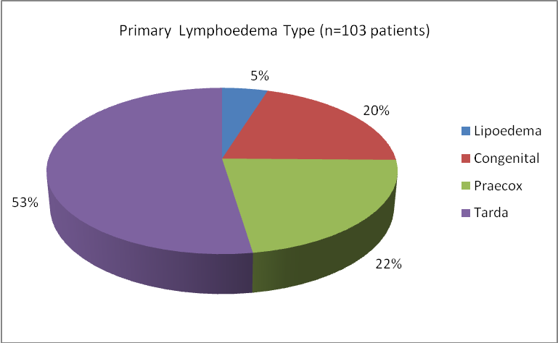

Graph 11: Primary Lymphoedema Type (n=103)

3.8.2 Non-cancer related secondary lymphoedema
Secondary lymphoedema in the western world is mostly caused by trauma or tissue damage, malignant or venous disease. Post infectious lymphoedemas are caused by filariasis in tropical areas, and by cellulitis in occidental (western) areas.

An overall total of 49.24% (2011 figures - 42.6%) of all recorded patients were recorded as secondary (non-cancer). Table 7/graphs 12 and 13 provide the breakdown of subgroup ICD code aetiology, unfortunately not all upper limb records have a completed code (only 25%) and therefore the table provides only a trend of the actual sub-population and not a full breakdown. The lower limb list show that some patients have had multiple causes as the total causes (1064) exceeds the total number of records (1015).

Table 7: Non-cancer aetiology
Cause classification | Upper limb (124 records) | Lower limb (1015 records)
Cellulitis | 2 | 120
Unclassified | 18 | 172
Acute lymphangitis | 0 | 1
Dependency | 3 | 325
Lipoedema | 0 | 26
Obesity | 3 | 172
Venous related | 5 | 248
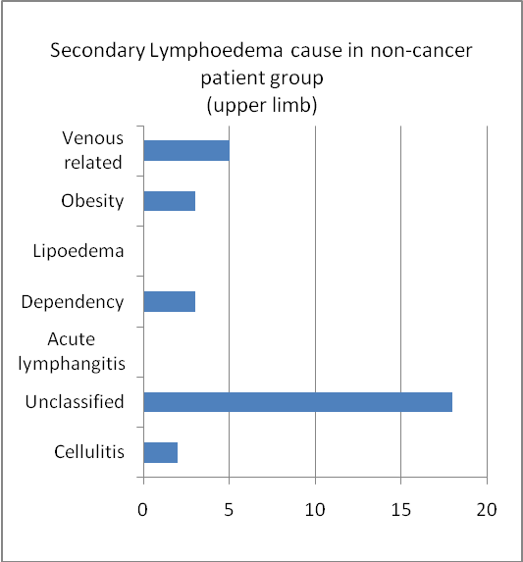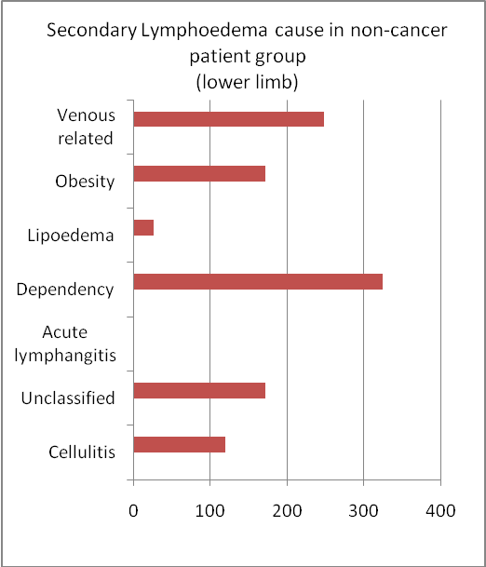

Graph 12 and 13: Cause of secondary lymphoedema in non-cancer patient group (n=1095)

It was surprising, but perhaps not unexpected to see the figures for the obesity and dependency sub-groups; this relates back to the outcomes from the Complex Clinic results which highlighted immobility, reduction in function and obesity as common co-existing conditions which, in themselves, will influence lymphoedema development.

Table 8: staging data for secondary (non-cancer) presentations
 | Stage 0 | Stage 1 | Stage 2 | Stage 3
Upper limb (78.25% staging uploaded) | 3 | 44 | 50 | 0
Lower limb (87.59% staging uploaded) | 22 | 378 | 448 | 41
Other areas e.g. H&N, genital (100% staging uploaded) | 1 | 3 | 7 | 4
Totals | 26 | 425 | 505 | 45

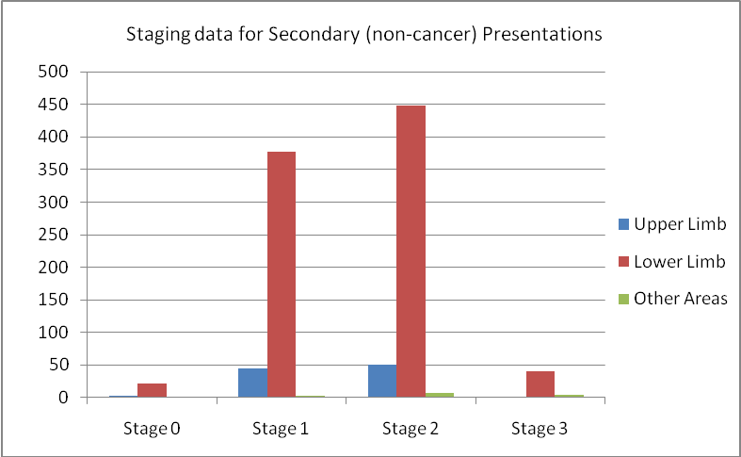

Graph 14: Staging for secondary (non-cancer) presentations

3.8.3 Cancer-related lymphoedema
A total of 1071 cancer-related records were reported (46.31% of the total population (54.75% for 2011)). Table 9/graph 15 provides a breakdown of the various tumour types associated with the main area of lymphoedema presentation: this has been broken down into 2 sub groups of primary areas of swelling: upper and lower limb. This table records the primary area of swelling to attempt to provide an overview of tumour site linkage and local incidence.

Table 9: cancer–related aetiology 1071 records (some ICD information gaps evident):
Cause classification | Main presentation in upper limb (843 patients) | Main presentation in lower limb (248 patients)
Cellulitis | 2 | 6
Breast cancer | 795 | 11
Gynae cancer | 8 | 113
Melanoma | 9 | 13
Urology | 0 | 14
Head and neck cancers | 2 | 1
Cancer other | 22 | 65

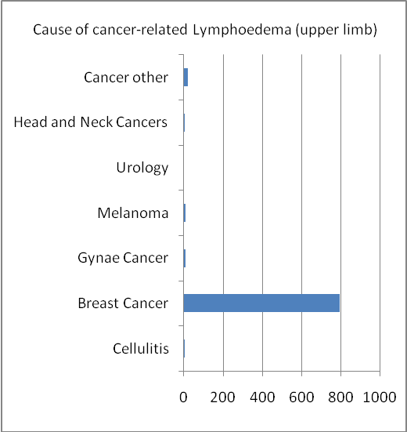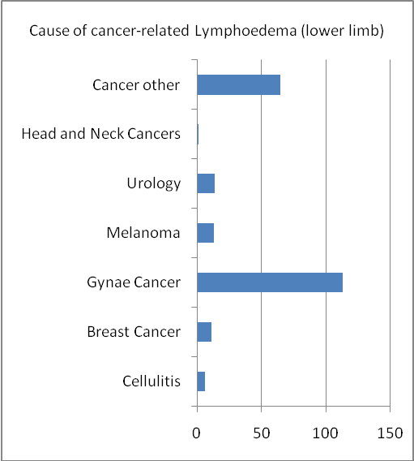

Graph 15: Causes of cancer related lymphoedema (n=1071)

Not surprisingly, the majority of cancer-related cases are associated with breast cancer however the increase in 2012 has been relatively low at only 150 new records i.e. an increase of 18.87 on 2011. The recent move to sentinel node biopsy and potential reduction in lymphoedema risk levels will provide interesting future data to continue this comparison. The increasingly radical gynaecological cancer treatments may also lead to an increase in this population and will require monitoring; the 2012 figure is an increase of 25.66% on 2011. The levels associated with urological and head and neck cancers are surprisingly low. The “cancer other” section may represent the palliative care element of this population where the tumour is not sub classified by the Lymphdat listing. The project team agreed that it would be unfeasible to include all tumour groups in a working clinical tool.

Table 10: staging data for secondary cancer-related presentations
 | Stage 0 | Stage 1 | Stage 2 | Stage 3
Upper limb (73.67% staging uploaded) | 47 | 312 | 259 | 3
Lower limb(87.5% staging uploaded) | 10 | 83 | 122 | 2

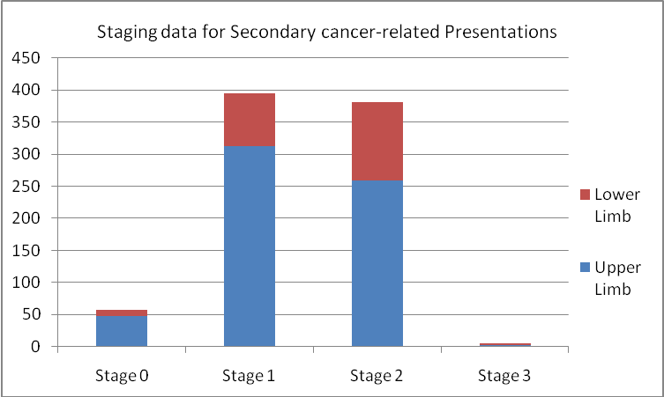

Graph 16: Staging data for secondary cancer-related presentations

3.8.4 Summary of aetiology
Overall the aetiology breakdown shows:

- Primary 4.45%
- Secondary (non-cancer related) 49.24%
- Secondary (cancer-related) 46.31%

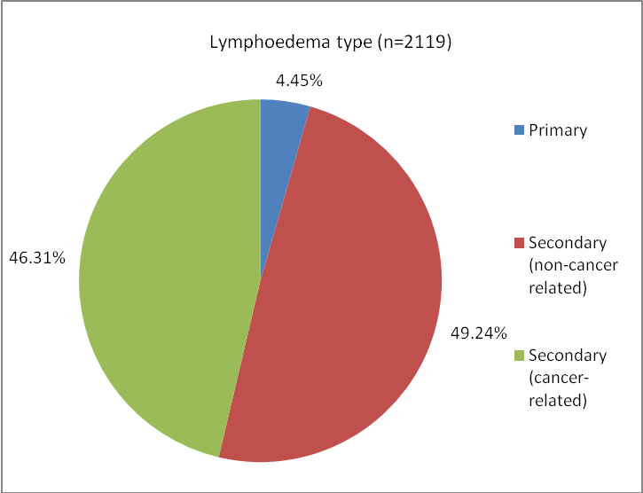

Graph 17: Lymphoedema type n=2119

This shows another definite change in the trend of case division; prior to 2008 the vast majority of cases would have been cancer-related, mostly as a result of funded staffing being associated with cancer, and very little for non-cancer. This statistic is evidence of increasing equity for all lymphoedema sufferers.

The primary figure has risen significantly for the region, reflecting the trend expected by literature research.

4.0 Conclusion
This report does not reflect all regional data as minimal data was uploaded from the Southern HSC Trust. The results do however demonstrate the positive impact of the key LNNI development strategies regarding potential patient groups and referrers. The continued move away from a majority cancer-related service is a dramatic improvement for the region’s service users compared to pre-2008.

A remaining concern is the increasing level of obesity recorded in the general population. A 2011 LNNI literature review regarding the impact of increased body weight has shown that obesity not only impacts on the quantity of lymphoedema improvement, but also the long term maintenance of the improvement. This is reflected across the Western World. The role of health promotion is now central to all interventions with a greater expectation of each individual service user to address weight gain and reduced activity levels with support provided by the teams and other health or council schemes. This issue has both outcome and health and safety concerns, and has been agreed by the project team to be an important focus for future review. In respect of the findings, the LNNI Board agreed to sponsor the purchase of additional bariatric equipment for the teams.

This review has demonstrated Lymphdat’s ability to report demographical and aetiological outcomes. As the process and tool continue to be refined, and data collection continues, it will beneficial to compare cross-regional, nationally and even internationally.

5.0 References

Williams AE, Bergl s, Tywcross RG (1996). A 5-year review of a lymphoedema service. European Journal of Cancer care; 5 (1): 56-59

CREST (2008) Guidelines for the diagnosis, assessment and management of lymphoedema. www.dhsspsni.gov.uk/index/hss/gain.htm

National Institute for Health and Clinical Excellence (NICE) (2006) Obesity: guidance on the prevention identification, assessment and management of overweight and obesity in adults and children (guideline 43).
www.nice.org.uk

Rockson SG (2001). Lymphoedema
American Journal of medicine; 110 (4):288-95

Baskerville p (1989). Primary Lymphoedema
Surgery; 65: 1550-5

Smeltzer DM, Stickler GB, Schirger A (1985). Primary lymphoedema in children and adolescents: a follow up study and review. Pediatrics. 76: 206 - 18

LNNI 2010 Audit Report of Lymphoedema Complex Clinics
www.lnni.org

Appendix 1: ICD codes and sub categories - Aetiological divisions of lymphoedema

ICD 10 category & description | Sub category | Description
Code 197-2  Postmastectomy lymphoedema syndrome | CB | Cancer related (breast)
Code 189-0  Lymphoedema, not elsewhere classified | CG | Cancer related (gynaecology)
Code 189-0  Lymphoedema, not elsewhere classified | CU | Cancer related (urology)
Code 189-0  Lymphoedema, not elsewhere classified | CHN | Cancer related (head and neck)
Code 189-0  Lymphoedema, not elsewhere classified | COTH | Cancer (other)
Code 189-0  Lymphoedema, not elsewhere classified | CMel | Cancer (melanoma)
Code 189-0  Lymphoedema, not elsewhere classified | COTH | Cancer (other)
Code 189-0  Lymphoedema, not elsewhere classified | NCP | Non cancer primary lymphoedema
Code 189-0  Lymphoedema, not elsewhere classified | NCV | Non cancer venous related
Code 189-0  Lymphoedema, not elsewhere classified | NCLIP | Non cancer lipoedema
Code 189-0  Lymphoedema, not elsewhere classified | NCDEP | Non cancer dependency
Code 189-0  Lymphoedema, not elsewhere classified | NCO | Non cancer obese
Code Q82.0  Hereditary lymphoedema | Hereditary lymphoedema | Familial lymphoedema
Code LO3  Acute lymphangitis | CELL | Cellulitis
Code B74.0  Filariasis |  | filariasis due to Wuchereria bancrofti
Code B74.1  Filariasis |  | filariasis due to Brugia malayi
Code B74.8  Filariasis |  | other filariases
Code B74.9  Filariasis |  | filariasis, unspecified

